Πλακέτα προστασίας BMS 4S 100A για μπαταρίες LiFePO4 – Data Sheet
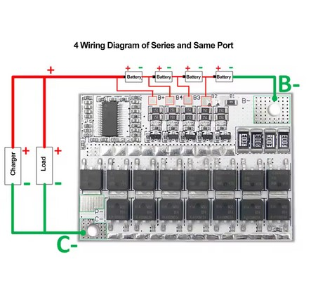

Product Specifications:
- Protection Circuit Board Type: 3S/4S/5S BMS
- Compatible Battery Types: LiFePO4 Ternary Lithium, Li-polymer
- Output Current: 80A (separate port), 60A (same port)
- Operating Temperature: 105℃ (≤ diymore)
- Package Contents: Battery Protection Board*1
- Safety Tip: Use a special lithium battery charger, avoid using lead-acid chargers.
|1s Bms Wiring Diagram|
**Advanced Battery Protection**
The 3S/4S/5S BMS is an essential component for safeguarding your high-capacity LiFePO4, Ternary Lithium, or Li-polymer batteries. This robust protection circuit board is designed to maintain the integrity and performance of your batteries, ensuring a longer lifespan and safer operation. With a robust output current of 80A on separate ports and 60A on the same port, it's capable of handling high-demand applications.
**Versatile Compatibility and Easy Installation**
The BMS is compatible with a variety of battery configurations, including 3S, 4S, and 5S arrangements, making it a versatile choice for various projects. The module comes with a detailed hands-on guide to help with installation, ensuring a hassle-free setup. The package includes a battery protection board, ready for immediate use. To ensure optimal performance, it's critical to use a specialized lithium battery charger, avoiding the use of lead-acid chargers that may lead to overcharging and damage to the MOS tubes of the circuit board.
**Reliable Performance in Demanding Environments**
Designed to withstand extreme conditions, the 3S/4S/5S BMS operates reliably at temperatures up to 105℃, ensuring it can handle the heat of high-performance applications. The module's compact design and lightweight construction make it an ideal choice for various projects where size and weight are critical. With its ability to balance charge multiple batteries simultaneously, this BMS is not just a safeguard but also a key component in maintaining the efficiency and performance of your battery systems.

Parameter:
Pin mode:
P-: negative pole of load C-: negative pole of charger B-: negative pole of battery
Hands-on guide:
Output current: separate port 80A; same port 60A
Note: Lithium batteries should be charged with a special charger for lithium batteries. Do not use lead-acid battery chargers. Lead-acid charging may cause high voltage to break down the MOS tube of the protection board, causing the protection board to be overcharged and not protected.
3-series sub-port wiring method (refer to the 3-series sub-port wiring diagram):
①Connect the 3 battery packs in series according to the battery connection method in the 3-series split port wiring diagram.
②Connect the negative pole of the charger to C- of the protection board, and the negative pole of the load to P-.
③Connect the positive pole of the charger and the load to the positive pole of the 3-series battery.
④Refer to the 3-series split port wiring diagram and connect the positive poles of the 3 battery packs to B+, B4, and B3 in sequence with 3 wires.
⑤Connect the negative poles of the 3 strings of batteries to B-. B1, B2 and B- are shorted.
⑥After all the wires are connected according to the 3-series sub-port wiring diagram, check whether they are correct, and then start to use after confirming that they are correct.
⑦During use, when the indicator light on the protection board is on, it means that the corresponding battery pack is in a balanced working state (that is, the battery is unbalanced at this time).

